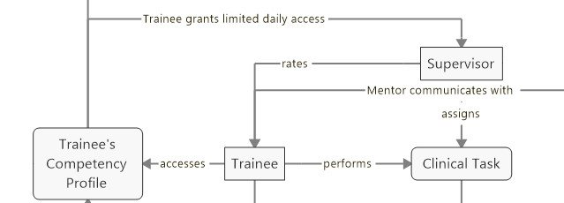

Trainee: who is taking the training course and supervised and rated daily tasks by supervisor.

Supervisor: who takes responsible for assigning tasks for trainees and follows up with trainees in order to document what trainees do during the training course.

Clinical Task: task that will be assigned for trainees to do in the hospital.

Trainee’s Competency Profile: Database that stores trainee’s daily activities.

Rating process between Trainer and Trainee:

1. A trainer sees the trainee’s profile
2. The trainer assigns a clinical task for trainee by telling him/her what he/she has to do
3. Then trainee performs that task.
4. The trainer stands close to trainer to observe how he/she does the task.
5. Meanwhile, the trainer also chooses name, task, complexity of which the trainee does
6. After trainee finishes, the trainer will rate trainee based on 5-scale EPAs. And submit data point to trainee’s profile.
7. Then the trainer will talk to trainee that how he/she has done the task.

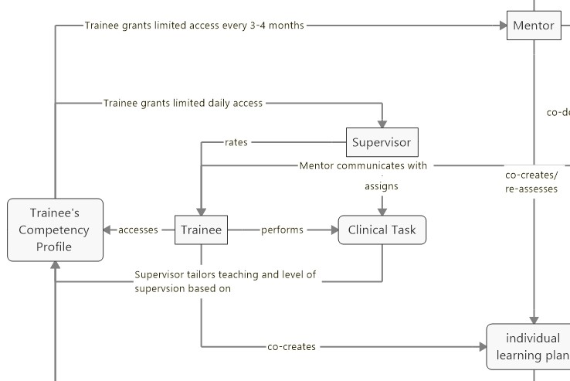

Mentor : supervisors who are responsible for 7-8 residents. they will meet every half a year to discuss the progress of the trainee.

Individual Learning Plan: learning plan created for trainee to improve his/her skills.

Learning plan creating process

1. Trainee grants access for mentor to see his profile
2. Mentor sees trainee’s profile
3. Mentor communicates with trainees in order to co-create planning plan

S